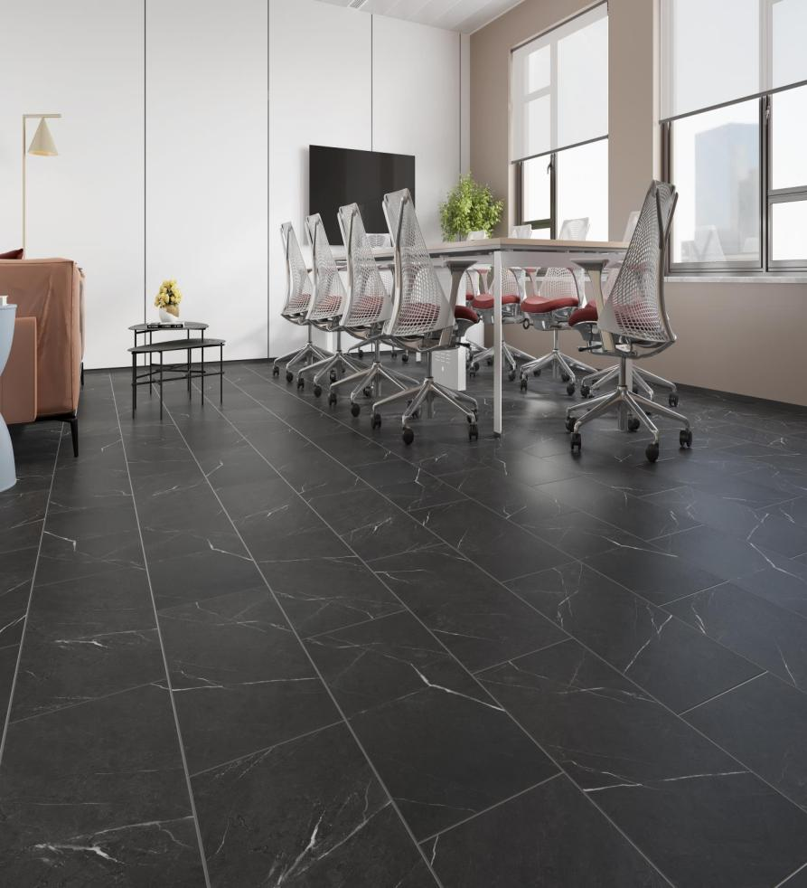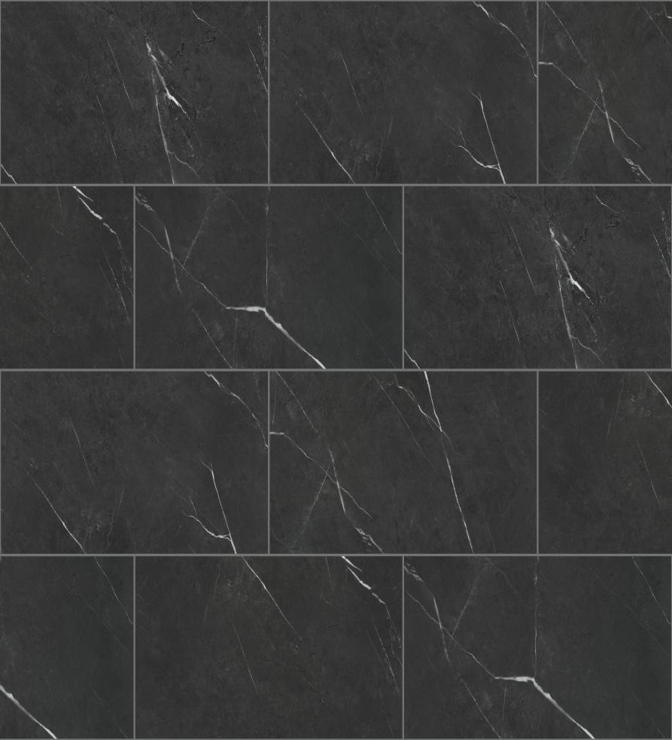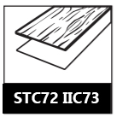

Width: 12 ”

Length : 24”

Thickness: 7.5mm

Wear Layer: 0.5mm (20 mil )

Finish : Sanded Grout line Look

Underlay: Attached EVA Pad

Sound rating: IIC 73 STC72

GARNET

Radiant Heat Compliant

**Butchart Collection**

**SPC Rigid Core Luxury Vinyl Plank**